SMA male to SMA female
RF Cable assembly SMA male to SMA female flange with 4 holes connector for RG316 cable
Quick Details
Model Number:SMA male to SMA female connector for RG316 cable
Type:RF cable
Place of Origin: Xian, China
Brand Name: Honor/KNT
Number of Conductors:1
Product name:RF cable SMA male to BNC female RG316
Connector A: SMA female Flange with 4-holes (or customized)
Connector B: SMA male (or customized)
Color:gold
Cable length:0.2M (Can be customized for your required length)
Conductor Material: brass
Package: Ploybag,carton

RF cable assemblies widely used in micro-wave test equipment
Cable Type : RG316
Working Voltage:DC 2.0V - 5.0V
Center Frequency:10mA-30mA
Output Impednace:50 OHM
Outer Band Attenuation:20dBi
Amplifier Gain : 5dBi±3dBi
Noise Figure :≤1.5dBi
V.S.W.R :≤1.5dBi
Operating Temperature -40°C - +85 °C

Products usdage :
1, GSM antenna ,tv antenna
2,wifi antenna , talkie walkie antenna
3,PCB connector

Advantage : It is very smart which is easy to move ,also high gain can amplified signal
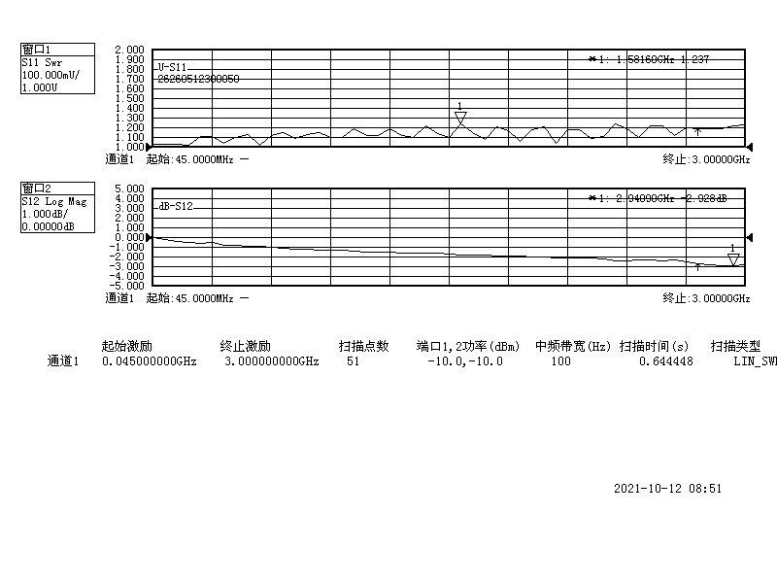
Our main products are

Rf Qma Connector RF Coaxial Connector
Rf Adapters Smb To Smc RF Connector Adapter
Rf Adapters N To Bnc RF Connector Adapter
Plug To Plug Adapter Connector RF Connector Adapter
Ssma Flange Mount Connectors SSMA RF Connector
Rp-smb Connector SMB RF Connector
Smz Coaxial Connector SMZ Connector
Welcome contact with us feel free for your special requirement. Call us or write to us now !

